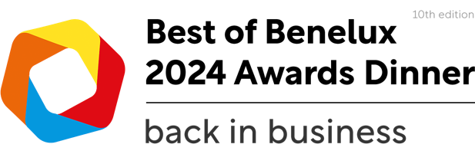
The KBC Best Company Award
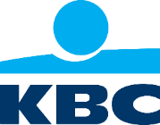
Application form
The KBC Company Award acknowledges companies which have shown that they have beyond doubt risen above the rest in their industry. Accurately adjusting and shaping themselves towards their constantly changing client expectations and demands.
Procedure
March 29, 2024 | Applications need to be submitted to shanghai@bencham.org.
April 8, 2024 | The Benelux Chamber Executive Committee will review all eligible applicants and choose 3 finalists.
April 8, 2024 | All the finalists will be announced through Benelux Chamber media and pre-voting will start, accounting for 50% of total votes. Benelux Chamber will promote the event and voting frequently in all its communication channels. But finalists should create their own buzz to get votes.
May 31, 2024 | During the event all 3 finalists will give an on-stage presentation.  Attendees will get the chance to vote for their preferred winner. This live-voting accounts for the remaining 50% of total votes.

Criteria Best Company Award
Show us why you think your company should win this award. Think out of the box! Submit written text, power point, videos, clipping etc. whatever you deem necessary to convince us that your company meets the following four criteria:
- Visibility
- Brand awareness
- Positioning in the market
- Co-operation with stakeholders
- Building the bridge between China and HQ

Eligibility
The Award requirements are that an entrant should be a Belgian, Dutch or Luxembourg-owned company active in Mainland China. Joint-ventures may also enter provided that they are at least 50% Belgian, Dutch or Luxembourg-owned. An entrant must be or become a member of the Benelux Chamber.

Pricing
On March 24th, our Executive Committee will shortlist 3 to 5 finalists who will move forward to the voting rounds! Signing up for the event as a candidate is free of charge. However, finalists are expected to be present during the Best of Benelux Awards Dinner to let them present their company one last time to the audience. Seating needs to be confirmed at least 1 week before the event.
Member Ticket | ¥ 1,388.00
Corporate Table (10) | ¥16,000.00
Half Corporate table (5) | ¥ 8,000.00
Event Sponsor Gold | ¥35,000.00
Event Sponsor Silver | ¥25,000.00
Friends Table | ¥11,000.00
Non-member Ticket | ¥ 1,688.00

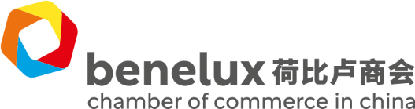
Company information
Company name
Company website
Number of employees in China
Number of years established in China

Company introduction (max. 550 characters incl. spaces – this will be used for communication purposes)
Please email us a high resolution image of your company logo (to be used for communication)
Contact information
Contact person
Email address
Phone number

Summary
Please tell us why your company should win this award within 800 – 1100 characters incl. spaces (this will be used for pre-voting communication purposes.

